MyMenu

1. 通过MyMenu调用窗体frmMRPCalQryRes



frmMRPCalQryRes

2. frmMRPCalQryRes 的Sub Form_Load()中调用查询

通过 Private Sub FilterBtn_Click() '查询

sSql = "select * from my_v_MrpInfo " & frmFilter.sWhereAndOrderBySql

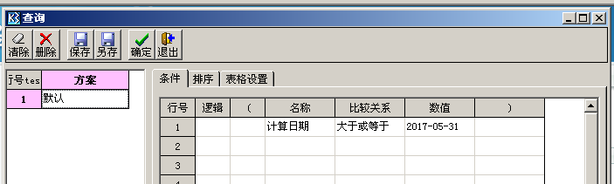

3. Private Sub SetContent() 结合查询 sSql 查询出列表

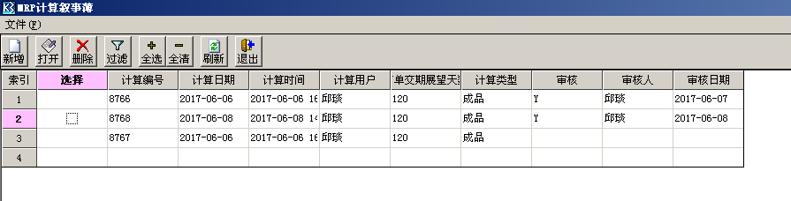

选择索引,点击打开

Case 8 '打开

If MyCheckRight(99999, 2, 1, iK3UserID) = False Then Exit Sub ‘检查人员的权限

Call EditBill

调用

Private Sub EditBill()

If Grid1.ActiveCell.Row = 0 Or Grid1.Cell(Grid1.ActiveCell.Row, iBillNoCol).Text = "" Then

MsgBox "请选择单据!"

Exit Sub

End If

frmMrpCal.strBillNo = Grid1.Cell(Grid1.ActiveCell.Row, iBillNoCol).Text

' frmMrpCal.bFirstLoad = False

frmMrpCal.Show vbModal

Unload frmMrpCal

' Call SetContent

End Sub

frmMrpCal

4.打开MRP计算

4.1 选择计算类型,当选择”计算类型” 的时候会触发

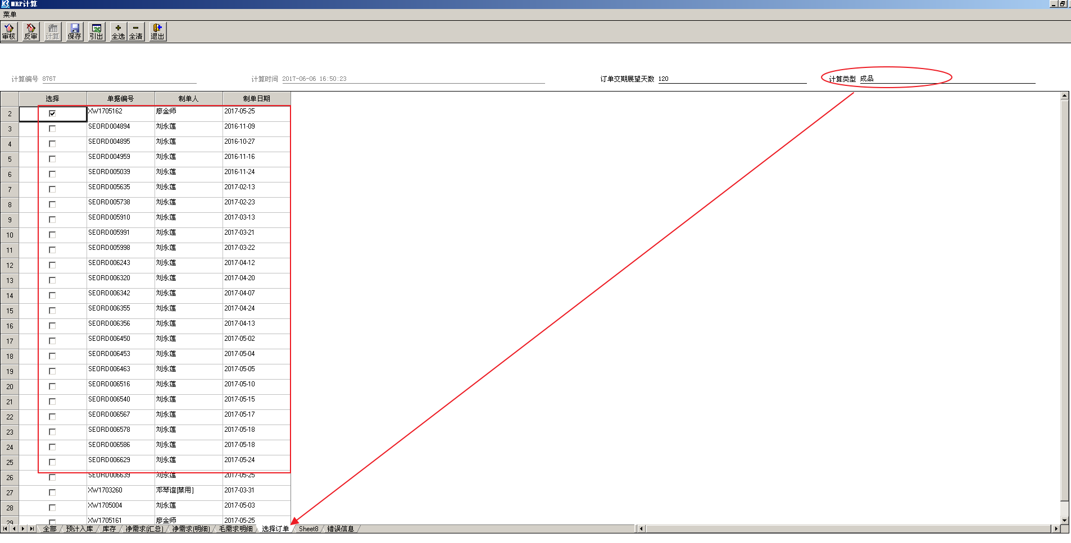

Private Sub InputTool1_Change(Index As Integer)

If Index = 2 And Toolbar1.Buttons(5).Enabled = True And InputTool1(2).Text <> "" Then

fpSpread1.ActiveSheet = 7

If InputTool1(2).Text = "成品" Then

iItemType = 0

ElseIf InputTool1(2).Text = "半成品" Then

iItemType = 1

ElseIf InputTool1(2).Text = "常规物料" Then

iItemType = 2

ElseIf InputTool1(2).Text = "包材" Then

iItemType = 3

ElseIf InputTool1(2).Text = "芯片" Then

iItemType = 4

End If

Call InitFPSpread(7, "参与运算订单", "My_P_GetMrpSeorder " & iItemType)

End If

End Sub

4.2 点击 ”计算”

4.2.1.将 4.1 的结果 插入 my_t_MrpSeOrder

4.2.2 将